# Review Questions

## Week 5 - Photoshop

1. Why would you resize an image in Photoshop instead of with HTML or CSS?

Resize an image through Photoshop because it retains the quality of the image. Photoshop will adjust the height as I change the width to maintain the aspect ratio (ratio of the width to the height of an image or screen).

1. What kind of image data does the jpg, png 8, png 24 and gif work best for?

Jpg: Browser, millions of colors

Png 8: transparency (1-bit), browser, 256 colors

Png 24: transparency (Alpha transparency), Animation (APNG: not well supported), millions of colors

Gif: transparency, animation, browser, 256 colors

SVG: transparency, animation, browser, vector, lots

1. What is whitespace?

In page layout, illustration and sculpture, white space is often referred to as negative space. It is the portion of a page left unmarked: margins, gutters, and space between columns, lines of type, graphics, figures, or objects drawn or depicted.

## Week 6 – wireframes and Intro CSS

1. What is the purpose of a wireframe? Where does the wireframe fit into the week 7 website development lifecycle?

Purpose: allows us to design basic layout of a website without thinking about design. Help focus on user experience.

It is in the design stage of the website development lifecycle.

Website development lifecycle

• Define Project – Gather Information, Understand Audience and Competitors, Develop Requirements

• Planning – Create Project Timeline, Develop Budget, Gather Media and Copy

• Design – Wireframe, Sitemap, Style Document, Mockup Site Design

• Develop – Write HTML, CSS, JavaScript, SEO and Accessibility

• Test and Deploy – Test Usability and Functionality, Launch Website

• Maintain – Update Site

1. What is the difference between an inline, embedded or linked stylesheet?

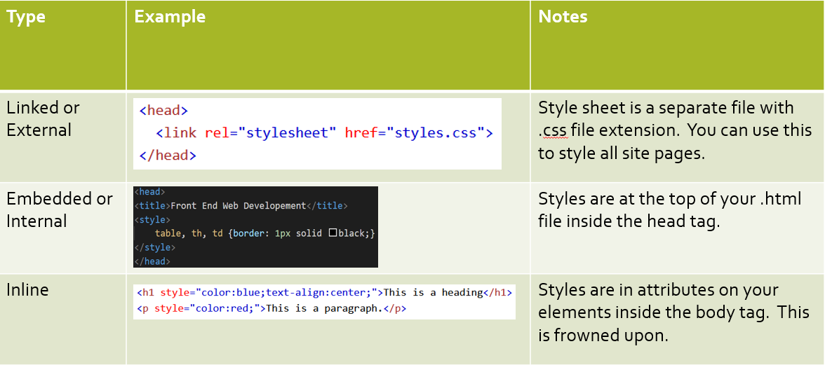

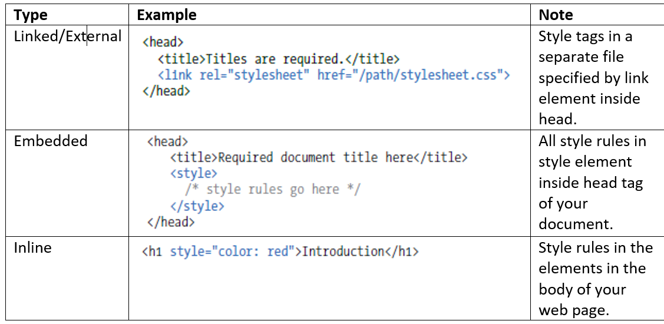

1. What is CSS inheritance?

The inherit CSS keyword causes the element for which it is specified to take the computed value of the property from its parent element. It can be applied to any CSS property, including the CSS shorthand all. For inherited properties, this reinforces the default behavior, and is only needed to override another rule.

1. What happens when two styles are applied to an element? How does the browser decide which one to use?

The browser decides which to use based on the class/id. Whichever one is of a higher class. Class is an attribute that you can add to any element. It names the element for the purpose of styling it. Here is an element with the corresponding class selector. Note the period before the class name in the stylesheet. That period is how the web browser knows to look for a class attribute to apply the style to instead of an element.

|  |  |
| --- | --- |
| In your html page | <h1 class="special">Lorem Ipsum</h1> |
| In your CSS linked stylesheet | .special {color: purple} |

1. What is the DOM?

Document object model

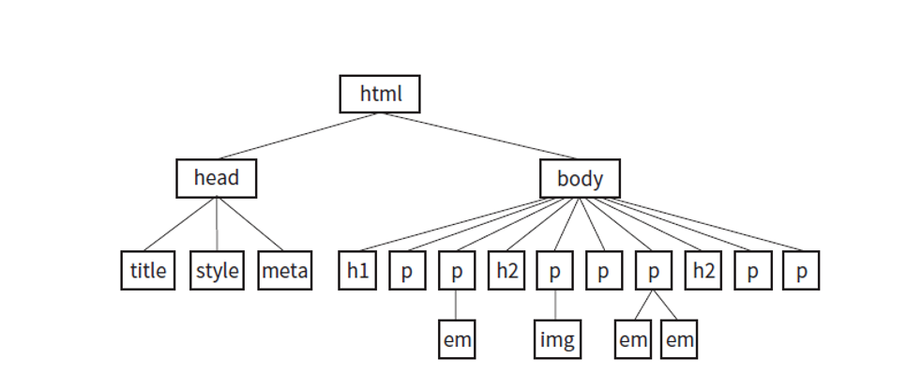 Because of the DOM every tag inside the body will inherit the font you choose, that is the style will cascade to the other elements. For example, in the graphic shown below the body tag contains h1, p, h2, em and img tags. All of them will have their font face changed by the rule we write below if applicable.

1. What are relatively sized fonts and why are they better than absolute/fixed size fonts?

|  |  |
| --- | --- |
| Absolute (not good for webpages) | Relative (good for webpages) |
| Have predefined meanings or real-world equivalents. They are not appropriate for web pages. | Relative units are based on the size of something else, such as the default text size. |

What is a CSS rule, selector and property? 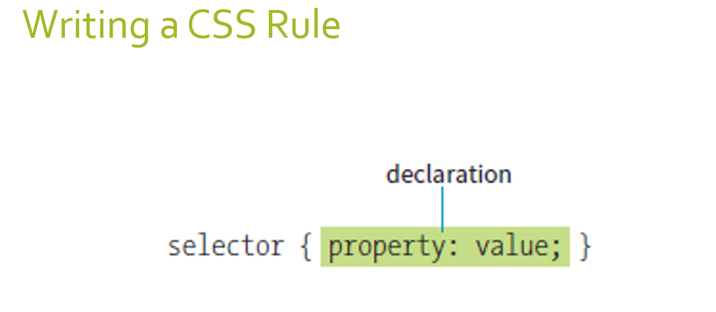 Replace selector with body, replace property with font-family and replace value with the fonts you chose.

1. What is the CSS id, element, grouped and class selector used for?

Grouped: Recall that if you have more than one selector you can group them in the selector area with commas in between like this 

Class: an attribute that you can add to any element. It names the element for the purpose of styling it. Here's an element with the corresponding class selector.

|  |  |
| --- | --- |
| In your html page | <h1 class="special">Lorem Ipsum</h1> |
| In your CSS linked stylesheet | .special {color: purple} |

What do the above look like in the CSS and in HTML? 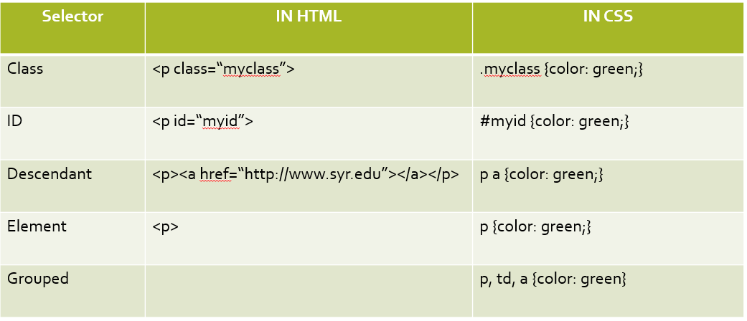

1. What are the css font and text properties we used in lab and their values?

Font family, font-size 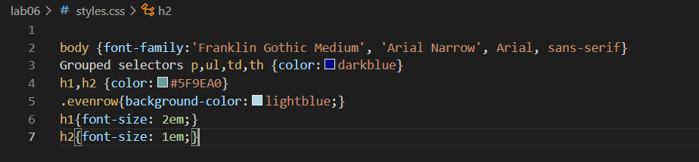

1. What does inspect element do in your browser?

Inspect Element allows you to preview changes without actually implementing them.

1. What does "web font" mean?

Web fonts are a CSS feature that allows you to specify font files to be downloaded along with your website as it is accessed, meaning that any browser that supports web fonts can have exactly the fonts you specify available to it.

1. Why is inline CSS a bad idea?

Inline css is bad especially when you have more complex page layouts, better to have the css separate from the html part portion.

## Week 7 – site maps, CSS Colors, backgrounds and box model

1. What is the web development lifecycle? Where does the site map fit into the lifecycle?

Website development lifecycle

• Define Project – Gather Information, Understand Audience and Competitors, Develop Requirements

• Planning – Create Project Timeline, Develop Budget, Gather Media and Copy

• Design – Wireframe, Sitemap, Style Document, Mockup Site Design

• Develop – Write HTML, CSS, JavaScript, SEO and Accessibility

• Test and Deploy – Test Usability and Functionality, Launch Website

• Maintain – Update Site

1. What is a style document (not stylesheet)?

A word document that tells you how you want to style your website in plain english

1. What do the numbers stand for in a hex color? 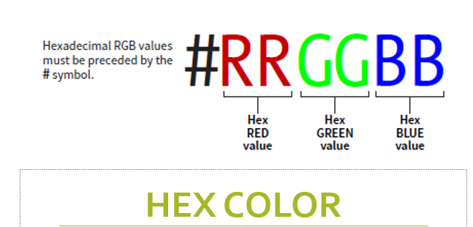
2. What is a pseudo selector? What can you do with a pseudo selector? What would the HTML styled by a pseudo selector look like?

A pseudo selector uses the name of an element combined with the state of the element. The styling applies to an element in a certain state; hover, visited, link, etc. and looks like this:

* selector:state {property: value}
* Applies a style to a state of an element.
* 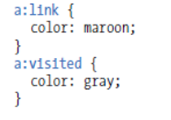 

1. What are some of the different pseudo states and what do they do?

Hover: change color if hover over link

Visited: color once the link is visited

Link: color of the link untouched

1. What is a descendant selector? What would the HTML styled by a descendant selector look like?

A descendant selector specifies the element that is the parent of the element and then specifies the element you are styling. The purpose is to only style an element that is inside another. For example, I could only style links that are inside a paragraph element. The syntax is as follows:

Parent_selector selector {property: value}

Example: nav a:hover {background-color: #??????;}

1. How do you specify a background color on an entire page?

body{

    background-image: url(images/logo_sized.png);

    background-color:#d19f6a; 🡨(ANSWER)

    background-size: 200px;}

    /*size the background image*/

1. What are the parts of the box model?

The CSS box model is a box that wraps around every HTML element. It consists of different properties you can style: margins, borders, padding, and the content.

1. What is the difference between a borders, margin and padding? 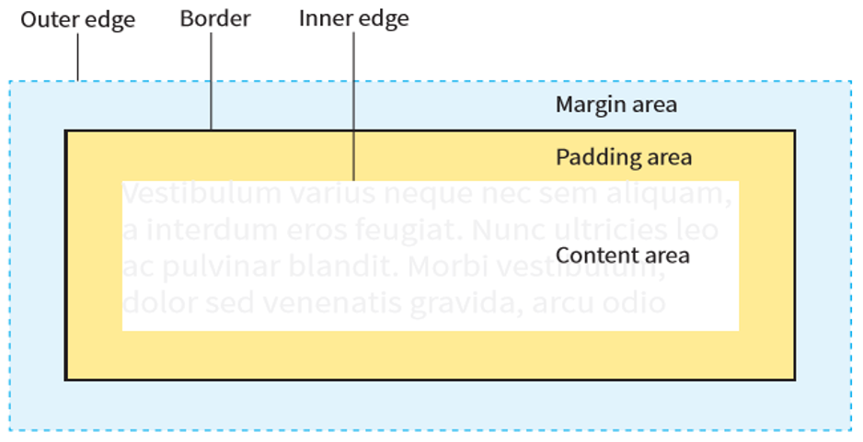
2. What happens when you use box model sizing on an inline element?  
   it would still do the same job, as on css, just less efficient

## Week 8 – CSS Layout

1. What is the purpose of semantic tags? What are the different tags and what are they used for?

Semantic tags should be on every web page defining the different areas. They allow us to style different sections of the page, help with accessibility so folks with screen readers understand what the different parts of your content. 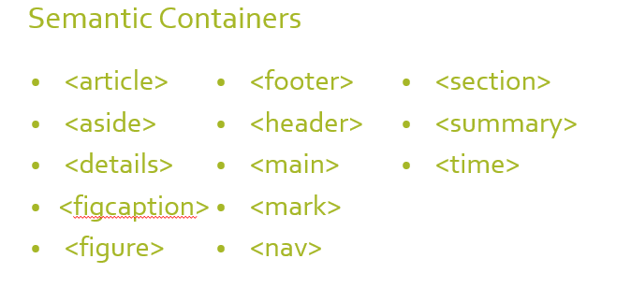

1. What is the purpose of div and span tags? What is the difference between them?

The span tag is perfect for this. Span is an inline container element, similar to div which is a block container element.

1. What does the CSS float property do?

The float CSS property places an element on the left or right side of its container, allowing text and inline elements to wrap around it. The element is removed from the normal flow of the page, though remains a part of the flow.

1. If an element has been floated, what happens to the content that occurs just after the float?

It will wrap around it.

1. What does the clear property do?

To stop the rest of the page from flowing around an element use the clear CSS property. 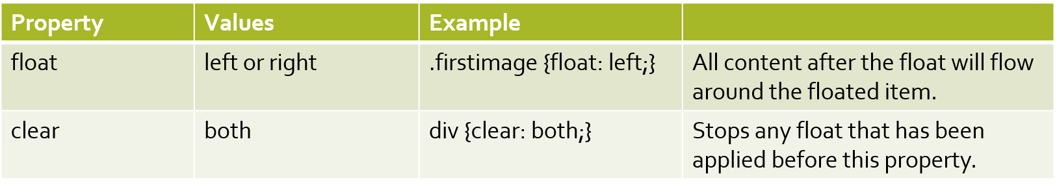

1. What is the purpose of flexbox?

Flexbox is a one-dimensional layout method for laying out items in rows or columns. Items flex to fill additional space and shrink to fit into smaller spaces.

1. Explain the parent child relationship involved with declaring and element display: flex.?

If you declare an element to be flex in CSS then it's immediate children elements will display side by side. In our case we are going to declare the div container with a class of part2 to be the parent. That means the 3 article tags are that elements immediate children.

1. What are the main properties used with flexbox and what do they do? 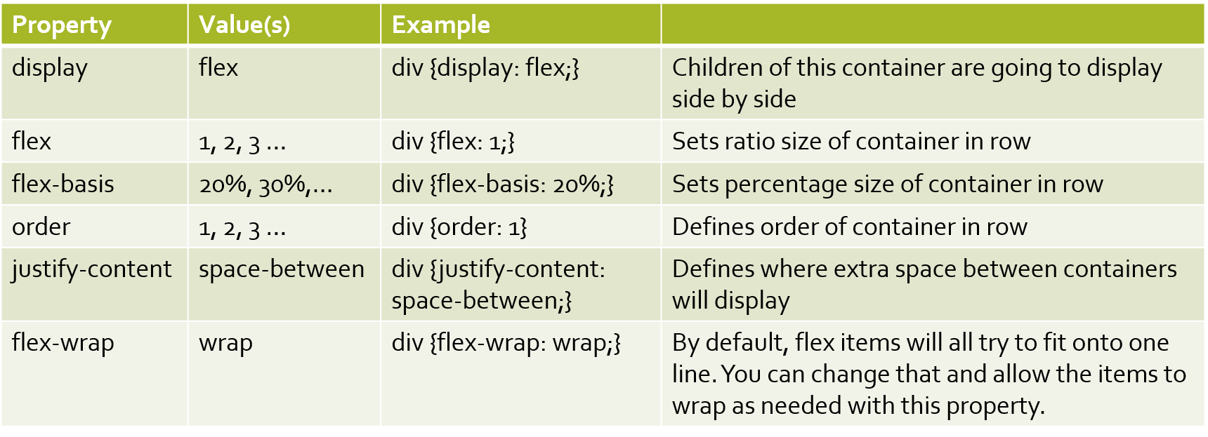
2. What does the border-radius property do?

Rounded corners are accomplished using the border-radius property.

## Week 9 – Responsive design

1. What is the viewport?

The browser's viewport is the area of the window in which web content can be seen. This is often not the same size as the rendered page, in which case the browser provides scrollbars

1. What meta tag allows our websites to load full size on a cell phone?

<meta name="viewpoint" content="width=device-width, initial-scale=1.0">

       <!-- ^^ this makes the page load full size on mobile-->

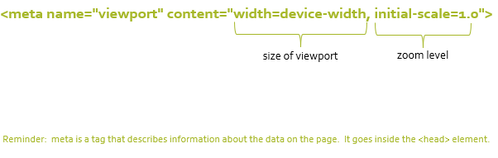

1. What does the max-width property do?

 .bannersmall{max-width:100%;}

  /*If it can be the max screen size, it will, other wise, it will just stay the same so that is to reserve the quality of the image (pixelation is a bad thing in web design*/

/*doesn't go past its file size, doesnt pixelate*/

/*Max-width is the preffered method */

1. How can you make a flexbox container box wrap to the next line on a smaller screen?

 .row1{display:flex; flex-wrap:wrap;}

 /*flex-wrap makes the text wrap if it doesn't fit on the website */

  .box1, .box2, .box3{flex:1;}

1. What is the purpose of a media query?

@media only screen and (max-width:600px)

            {body{background-color:orange;}

            /*the 600px in the media query is called a breakpoint*/

1. What does display: block do for an inline element?

By default, inline elements only take up the space from left to right that they need to display their content. To make an inline tag take up 100% of the horizontal space we need to convert it to block. Add the property display and the value block to the descendant selector you created above.